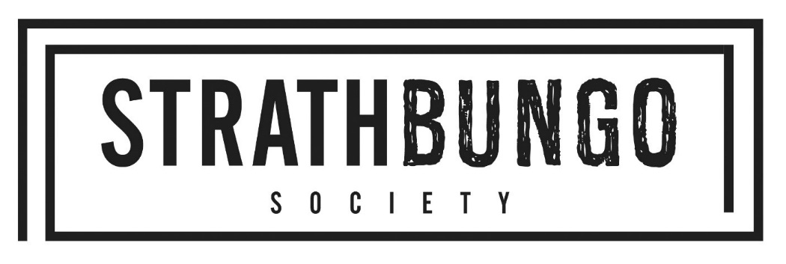

Minute of the Annual General Meeting
of the Strathbungo Society
12 November 2024
Draft: Pending acceptance at 2025 AGM
Present:
Paola Rezzilli, Steven Good, Andrew Downie, Rhys Crilley, Sharon Schweppes, Imelda Devlin, Kevin Kane, A Young, C Piacentini, J Smith, Fiona McKinnon, G Zwarma, David Black, James Cook, Stephen Lamb, Roberto Caviers, Daniel Thomas, Anthony Walsh, Paul Mullen, Holly Andrews, Reid, M Harper, Tom Nockolds, Karl Schweppes, Ann Donnie, Les Payto, Michael Lancaster, Richard Dye.
Apologies:
Cllr. Zen Ghani, Rhiannon Spear, Cllr. Norman McLeod, Nick Kemp, Jane Carolan, Duncan Gammie, Kem Gammie.
1. Welcome
Paola Rezzilli provided an overview of the societies aims and goals.
2. Approval of AGM Minute of 7th November 2024
Kevin Kane proposed to accept, seconded by Steve Good.
3. Annual Report and Accounts
Paola Rezzilli spoke to the pre-circulated Annual Report. She noted that Strathbungo had been identified by Time Out as one of the world’s coolest neighbourhoods, and only one of three in the UK. Main events - Windows Wanderland and Bungo in the Back Lanes. Thanks to providers of grants and participants at all events. Key issues in the area: fly tipping in the lanes, ban on pavement parking, lanes fund application to repair lanes. The Society keeps in touch through monthly meetings, the Strathbungo Newsletter, social media, and the blog, as well as Bygone Bungo.
Steven Good spoke to the pre-circulated Annual Accounts. There were no questions.

The Annual report and Annual Accounts were proposed for approval by Kevin Kane, and seconded by Daniel Thomas.
4. Election of office bearers:
Chair: Paola Rezzilli, nominated by Steve Goode seconded by Kevin Kane.
Vice chair: Duncan Gammie, nominated by Paola, seconded by Tom Nockolds.
Treasurer: Steven Good, nominated by Paola, seconded by Tom Nockolds.
Secretary: Rhys Crilley, nominated by Paola, seconded by Steve Good.
5. Election of Committee members:
Cllr Zen Ghani, Jane Carolan, Imelda Devlin, Kevin Kane, Fiona McKinnon, Andrew Downie, Marion Harper, Les Peyto, Eddie Barnes, Nick Kempe, Paul Mullen, Stephen Lamb, James Cook, Tom Nockolds, Holly Andrews, and Gimenne Zwama. Nominated and approved.
6. Guest speaker – Queen’s Park Neighbourhoods, Local Place Plan
Richard Dye of Queen’s Park Neighbourhoods. Noted that Battlefield Community Council and Shawlands and Strathbungo Community Council had funded and launched a Local Place Plan for the neighbourhoods surrounding Queen’s Park, including Strathbungo. The results of the Phase One community consultation had identified the following key issues/priorities: traffic calming, active travel, safety, public realm, maintenance and care, environment and sustainability, community assets (Langside Halls and Queen’s Park Glasshouse). Now at Stage Two where there is a second community consultation on prosed project priorities and there will be a community drop in event in February 2025 where the projects will be defined further. It is hoped that the finalised Local Place Plan will be completed by March 2025.
Questions:
How will the place plan be used to ensure that private developers develop future sites in line with the community’s needs? Place Plan can be used to suggest community-desired policy proposals.
How much can the LPP have an influence on how empty buildings in the area might be used? Decision taken to focus on Langside Halls and the Glasshouses, and things where we feel we can make a tangible impact.
7. AOB
Sharon Schweps moved to thank everyone who helped with and volunteered their team to clean up during Brighter Bungo, as well as the council, and Bossa bar & restaurant who provided free teas, coffees and hot chocolates for volunteers.
Sharon Schweps also raised the issue of bins in the area. Pointed out that if a townhouse is split into 3 then there will be 15 bins per house and that lanes are now very cluttered and messy. Asked what do we do with the bins that are full of rubbish and rain water and never collected?
Other attendees pointed out:
⁃ Issue of bins rarely being collected too.
⁃ Issue of fly tipping coming from the residents of Strathbungo.
⁃ Paola Rezzilli noted she has spoken to the NRS local area coordinator about the bins.
- Kevin Kane to raise the issue at the next meeting of Pollokshields Area Partnership.

Paola Rezzilli closed the meeting with thanks to attendees and highlighted that next committee meeting is on Tuesday at 7:30pm in the Bungo, Nithsdale Rd.

