Strathbungo Society communication to Moray Place residents / title holders

After 2 years of negotiation with the Strathbungo Society, assisted by elected representatives at both Council and Parliamentary level, Network Rail will shortly be writing with a revised proposal for new fencing to all residents and home owners with title extending over Moray Place.

Network Rail originally notified Moray Place residents on 7 January 2015 that they intended to erect a 1.8m (6ft) prison-style, weld-mesh fence along the entire length of Moray Place; Network Rail were not consulting owners, simply alerting them in advance to the likely noise and inconvenience.

From that date, the Strathbungo Society has sought to garner and represent the views of residents and the wider community and to impress upon Network Rail that it needed to engage with the community, respect Strathbungo’s Conservation Area status, recognise residents’ title ownership and the importance of our Moray Place ‘green corridor’. Importantly, Andrew Downie of the Society undertook considerable research on the legal boundary along Moray Place, helped by owners who provided copies of their title deeds. The result of this work clearly shows that the legal boundary runs in a straight line roughly 2 feet back from the road edge. This research clearly shows that the original ‘established’ boundary – the existing wall at 1-6 Moray Place, the wire and post fence at the Gardens (and in the past a rail-sleeper fence) and the original hedge, prior to the hooped fence– was approximately 3 feet behind the legal boundary. This approach of railways’ erecting fencing behind their legal boundary has been confirmed by Network Rail as its standard practice, as it affords them access for fence maintenance. The Society’s research has been accepted in full by Network Rail. In addition and from the outset, the Society challenged Network Rail to change the height and style of fencing for a location like Strathbungo. All these issues, title/ legal and established boundaries, height and appropriate style of fencing are now better addressed in Network Rail’s proposal.

Given the Society’s evidence-based research, Network Rail is now proposing to follow the line of the established boundary - the original wall/hedge/sleeper fence, 3 feet back from its legal boundary - and to remove all existing fencing. The fence design is much improved and would be as at the railway bridge at Titwood Road (see illustration below) and it6 will be no higher than 1.6m.
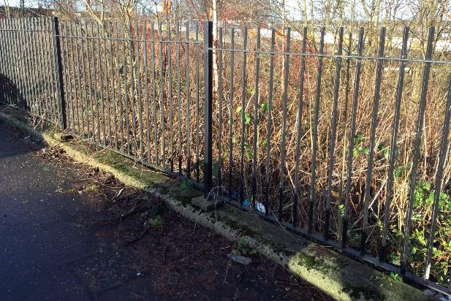
The works are to be carried out in early 2017 – most likely in February - prior to the nesting season, and will require a Council-approved day-time road closure order. Network Rail propose to undertake the works in two phases: first at the Gardens at the post and wire fence and then at the Squares at the hooped fence and up to wall at 6 Moray Place.

To the Society, Network Rail’s plan is a major improvement on its original one. It settles the issue of title and fence placement for the future, and the fence design and height is much-improved. It does, though, have significant implications for vegetation along Moray Place, as it will be necessary to remove most of the existing trees and shrubs to clear the fence line and provide a safe working space. It should be noted that Network Rail is within its rights to erect a fence of its choice on its land and to remove vegetation as appropriate to allow this to be done.

The Society recognises that in the short-to-medium term this will remove much of the ‘green corridor’ along Moray Place. Notwithstanding this inevitable loss of amenity, it does perhaps provide an opportunity to create a longer-term, sustainable planting plan for Moray Place, potentially along its whole length. The Society intends to work with Network Rail, the Council and other organisations and home owners to develop a replanting plan for Moray Place, and is hopeful that it can help attract external funding and support to make this happen.

Given Network Rail is set on erecting a fence on its own land and can do so without any external approval, the Strathbungo Society’s committee believes that all things considered Network Rail’s new proposals are as good an outcome as could be realistically achieved. The clearance of vegetation is an inevitable feature of the works, though the possibility exists that in the longer term it could allow the creation of a designed, sustainable, low-maintenance and attractive ‘green corridor’, using appropriate species of trees shrubs and plants.

Ultimately, these are Network Rail’s plans and it is for Moray Place owners to decide on their response. The Strathbungo Society believes that its work over the past 2 years has positively influenced Network Rail not only to significantly improve on its original plans, but to lay to rest the uncertainties as between the legal and “established” boundaries that have beset community relations with Network Rail over many years.

Finally and at the insistence of the Strathbungo Society, Network Rail has agreed to host (with Strathbungo Society committee members in attendance) a community drop-in event to allow Moray Place residents and the wider community to have their questions and queries answered. Importantly QTS, Network Rail’s contractors who will undertake the work, will also be in attendance.

The community drop-in event details will be held on:
Tuesday 6 December 2016, between 4pm – 6.45pm
Queens Park Baptist Church Hall, 180 Queens Drive
where members of the community can discuss with Network Rail its plans for Moray Place.

The Strathbungo Society
18 November 2016
If you wish to contact the Society on this issue, please do so at: adownie@doctors.org.uk

