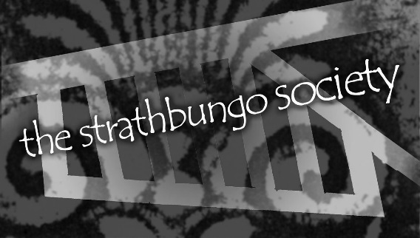
THE STRATHBUNGO SOCIETY
Minutes of Committee Meeting
Tuesday 16 February 2016
Basement, The Bungo, Nithsdale Road
Present: Kevin Kane (Chair), Nick Kempe (Treasurer), Carol Dobson (Secretary), Heather Alexander, Imelda Devlin, Loraine Forde, Phil Harvey, Scott Obrzud, James Powsey, Sharon Schweppes, Holly Ritchie
Apologies: Alison Hunter (Vice-Chair), Jane Carolan, Alan Dobson, Andrew Downie, Ann Downie, Rosie Ilett, Fiona MacKinnon
1. Welcome and introductions
Kevin Kane welcomed all members and noted apologies as listed above.
2. Minutes and Matters arising
Strathbungo News: Sharon emailed printer (Kestrel) to ask for their views on the colour print quality in latest edition. She sought an alternative quote from local printer Minuteman for £240.00 for a full colour print run. Given this is more competitive than Kestrel, members approved the proposal to accept the quote from Minuteman.
Missing bins etc.: Members were reminded that residents can report bin collection problems direct to GCC Land and Environmental Services (LES) via a LES app. It was agreed that we have a page on the Bungo blog that provides FAQs on rubbish collection and how to contact the Council. ACTION Heather agreed to draft a page and send to all committee members for comment.
3. Bungo in the Back Lanes
A Society funding application to the Pollokshields Area Partnership has been finalised and will be submitted by Nick to meet the submission date of 17 February 2016.
An initial BITBL planning session was held on 9 February 2016 and a draft action list was agreed. The next session is scheduled for 23 February in the Den, The Bungo, when previous key organisers (who have now moved out of the area) plan to attend to pass on their knowledge of the BITBL planning process. It was agreed that it would be useful to construct a ‘BitBL Planning Manual’ to help continuity and mitigate the risk of essential information being held by a few key people. ACTION: Carol to book the Den for 23 February 2016.

4. Strathbungo Spring Fling
Loraine provided an update on activity. Rosie has contacted local crafters and has agreement from twelve individuals to attend and pay a hire fee for stalls. Committee members, neighbours and friends are asked to support the event and particularly to provide donations of home baking. It was agreed that it be promoted via Streetlife and the Society’s Facebook page.
It was also agreed that Rosie buy 20 Bungo mugs at a cost of £50 for sale on the day and Members discussed purchasing more merchandise with the Bungo logo for the Fling / BITBL.
Promotional posters and leaflets are in hand and should be ready for distribution by 1st March.
It was agreed that the 1st prize for the Bake Off will be a ‘Bungo Star Baker’ apron.
ACTION: Heather agreed to investigate merchandise and circulate to members.
ACTION: Holly offered to make a video clip to promote the Bungo Bake Off
ACTION: The Spring Fling team will investigate additional prizes for the Bake Off
5. IT/Social Media update
Phil provided an update. Work in progress includes:
- setting up mailboxes for Society officer bearers
- checking and tidying up ownership of sites / addresses
- Facebook administration
- File sharing
- Posting and admin rights to FB and Blog
6. Membership / Friends scheme
The new ‘Friends’ leaflet has been distributed with the Strathbungo News. The aim is to expand the community funding base of the Society. It was agreed that the Friends scheme be promoted at the forthcoming Strathbungo Spring Fling.
ACTION: The IT group to investigate setting up a BT ‘My Donate’ page on the Blog to enable people to donate one-off donations to the Society.
7. East Pollokshields Charrette
Organisers have invited the Society to nominate a ‘Champion’ to represent Strathbungo. Ideas are to be sought for improving that part of Strathbungo that lies within the Charrette planning area (the ‘Nithsdales’ and Moray Place). ACTION: Nick to alert folks to walkabout on Sunday via the Blog / Facebook.
8. Brief Updates
Sammy Dow’s: Members heard that the most recent planning application is on hold as the wrong drawings were posted on the Council’s planning site. A tentative meeting has been set up by Fiona for her and Kevin to meet planning officers to discuss proposals and context. Significant concerns relate to overlooking / noise / smell issues to neighbouring properties and issues re. the fire escape and exit to the back lane.

Network Rail: Kevin has been in contact with the Head of Scotland PR at Network Rail to discuss their plans. We await clear proposals from Network Rail. The key issues are:
- the location of the boundary line between NR and private property
- the height and style of fencing
- lack of recognition of the conservation status of the area
There was a discussion as to whether the Society should take a proactive position and propose a solution to Network Rail, with no resolution.

Scottish Parliamentary elections – local hustings: ACTION: To be carried forward for discussion at next meeting (Secretary)
AOB: Kevin informed members that he has been invited to meet Stuart McDonald MP to discuss Southside tourism.

Date and time of next Committee meeting
Tuesday 15 March 2016 7.30pm, Basement, The Bungo, Nithsdale Road

